Assignment 2
Omar Al-Faiadh[201735167]
¹ UAE University, UAE
201735167@uaeu.ac.ae
Abstract. In this assignment, the conjoint analysis and regression analysis was applied on 18 products of sofa. These analyses were done to have a better understanding of the importance of each attribute in making a decision to choose the best sofa product. The data was collected using 1 response on a survey to rank the options based on preferences. The product’s attributes and attributes levels were explained, and many insights were driven out of the conjoint analysis and regression analysis.

Keywords: Conjoint Analysis, Regression Analysis, Sofa, Furniture, Marketing Analysis.
- Introduction:
In this assignment, I will use Conjoint Analysis and Regression Analysis to solve a common problem that happen in furniture markets, which is identifying the most important attributes that customers’ preferences depend on when they select the product they want to buy. I will explain the attributes of sofa, which are the product that I will focus on studying in this assignment, and the levels of each attribute. Then, I will conduct a survey to rank these different sofa products from worst to best to apply conjoint analysis and regression analysis on my data. According to Conjointly (n.d.), “conjoint analysis is a popular method of product and pricing research that uncovers consumers’ preferences.” The conjoint analysis is a useful analysis method in marketing because it measures the customers’ preferences for different attributes for a specific product, such as sofa in this assignment. I will explain the steps of the conjoint analysis with the insights that we can gain from it. Afterwards, I will conduct regression analysis on the data assess how buyers value different product attributes and study the relationship between the dependent variable (rank) and the independent variables we have on hand. Lastly, I will conclude by summarizing the insights and give some recommendations that would help furniture design to recognize the most attributes that attract the customers.
- Problem Description:
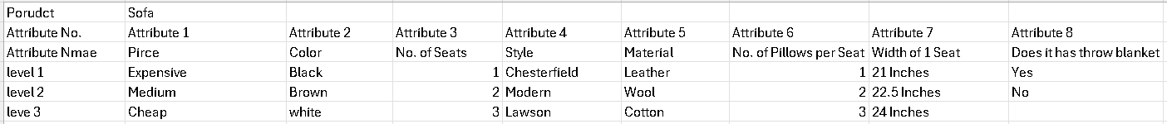
Figure1: product name, attributes, and attributes’ levels.

The problem that I’m trying to study in this assignment is about the product “sofa” and its different attributes. What are the most important attributes, and levels of attributes, in sofa that people build their preferences based on? In this case study, we will study, as we can see in Figure 1, the following attributes of sofa and their levels:
1-Price: this attribute classifies the price of a sofa.
Levels of Price: Expensive, Medium, and Cheap.
Dummy variable: -1 for expensive, 0 for medium, and 1 for cheap.

2-Color: this attribute classifies the color of the sofa.
Levels of Color: Black, White, and Brown.
Dummy variable: -1 for black, 0 for white, 1 for brown.

3-Number of seats: this attribute gives the number of seats within each sofa.
Levels of Number of seats: 1 seat, 2 seats, and 3 seats.
Dummy variable: -1 for 3 seats, 0 for 2 seats, and 1 for 1 seat.

4-Style: this attribute defines the style of each sofa.
Levels of Style: Modern, Lawson, and Chesterfield.
Dummy variable: -1 for Modern, 0 for Lawson, and 1 for Chesterfield.

5-Material: this attribute defines the material that each sofa was made of.
Levels of Material: Leather, Wool, and Cotton.
Dummy variable: -1 for Leather, 0 for Wool, and 1 for Cotton.

6-Number of pillows per seat: this attribute gives the number of pillows per each seat in sofa. For example, if the number of pillows per seat was 2 pillows per seat and the number of seats was 3, then the number of pillows in this sofa is 2 × 3 = 6.
Levels of Number of pillows per seat: 1 pillow, 2 pillows, and 3 pillows.
Dummy variable: -1 for 3 pillows, 0 for 2 pillows, and 1 for 1 pillow.

7-width of 1 seat: these attributes give the width of each seat, where there are 3 different width per seat sizes in our case.
Levels of Width of 1 seat: 21 Inches, 22.5 Inches, 24 Inches.
Dummy variable: -1 for 21Inches, 0 for 22.5 Inches, and 1 for 24 Inches.

8-Does it have thrown blanket: this attribute classifies whether there is a throw blanket or not for each sofa.
Levels of Does it has thrown blanket: Yes, and No.
Dummy variable: -1 for Yes, and 0 for No.
- Data collection and Characteristics:
  - Data collection:
The variables of attributes were generated using thinking methods such as brainstorming to generate possible important attributes in a product such as sofa. Product Number was generated to define the different combinations of the attributes that’s designed in an orthogonal design. Rank is the part of data collection, where a survey was conducted on 1 person to rank the 18 different sofa products (combinations of attributes in an orthogonal design).
  - Data characteristics:
-Product Number: it defines each combination of attributes in the case study.
Type: Categorical

-Price: this attribute classifies the price of sofa.
Type: Categorical, Dummy variable, where -1 for expensive, 0 for medium, and 1 for cheap.

-Color: this attribute classifies the color of the sofa.
Type: Categorical, Dummy variable, where -1 for black, 0 for white, 1 for brown.

-Number of seats: this attribute gives the number of seats within each sofa.
Type: Categorical, Dummy variable, where -1 for 3 seats, 0 for 2 seats, and 1 for 1 seat.

-Style: this attribute defines the style of each sofa.
Type: Categorical, Dummy variable, where -1 for Modern, 0 for Lawson, and 1 for Chesterfield.

-Material: this attribute defines the material that each sofa was made of.
Type: Categorical, Dummy variable, where -1 for Leather, 0 for Wool, and 1 for Cotton.

-Number of pillows per seat: this attribute gives the number of pillows per each seat in sofa. For example, if the number of pillows per seat was 2 pillows per seat and the number of seats was 3, then the number of pillows in this sofa is 2 × 3 = 6.
Type: Categorical, Dummy variable, where -1 for 3 pillows, 0 for 2 pillows, and 1 for 1 pillow.

-width of 1 seat: these attributes give the width of each seat, where there are 3 different width per seat sizes in our case.
Type: Categorical, Dummy variable, where -1 for 21Inches, 0 for 22.5 Inches, and 1 for 24 Inches.

-Does it has thrown blanket: this attribute classify whether there is a throw blanket or no for each sofa.
Type: Categorical, Dummy variable, where -1 for Yes, and 0 for No.

-Rank: the results of the survey show the ranking of each combination in the orthogonal design, where 1 is the least preferred combination and 18 is the most preferred combination.
Type: Categorical (ordinal).
- Conjoint Analysis:
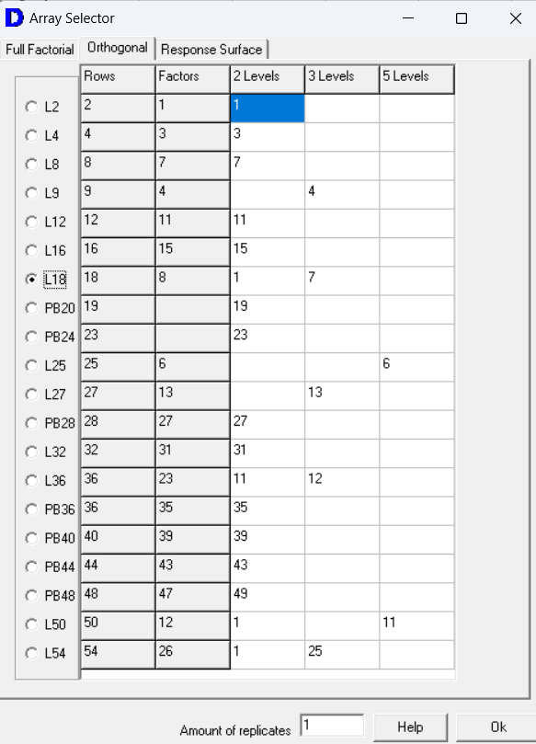
Figure 2: Orthogonal Matrix Design.
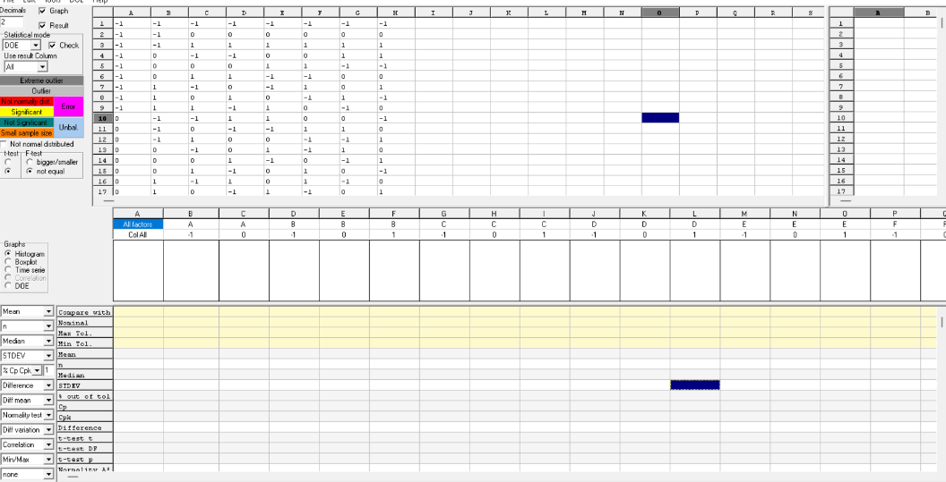
Figure 3: Orthogonal Matrix.
  - The selection of design for conjoint analysis:
I used Develve software to design the orthogonal design or matrix that’s used to study the different attributes, and their levels, of sofa. Figure 2, and 3 show screenshots of design that I selected in this case study. I selected L18 where it suits the number of attributes that I have, which is 8, and 7 of these attributes have 3 levels while 1 attribute has 2 levels. Figure 3 shows the design Develve generated. This design generates 18 different rows, which is a big enough number to conduct conjoint analysis.

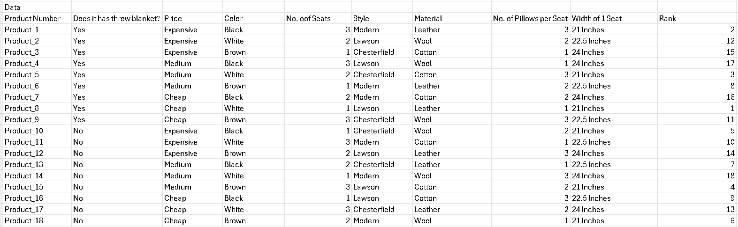
Figure 4: Dataset of Sofa’s Combinations and Their Rankings.
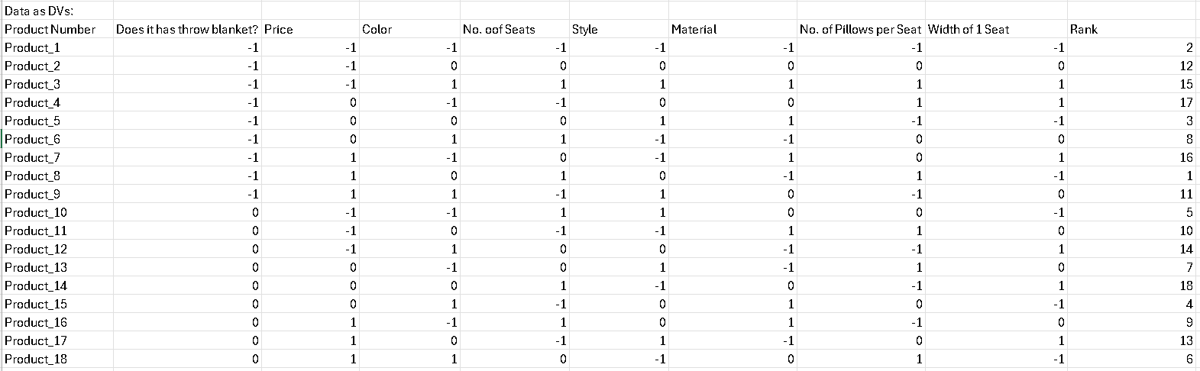
Figure 5: The Dataset Represented by Dummy Variables.
  - Survey and ranks:
Figure 4 shows the survey conducted. In this survey, I asked 1 person to rank 18 different kinds of sofa. The ranking was done by assuming that 1 is the worst and 18 is the best. The results of the survey is shown in Figure 4 at the last column called “Rank”. In Figure 5, I used the dummy variables that I defined earlier to allow the data to be analyzed using conjoint analysis and regression analysis.

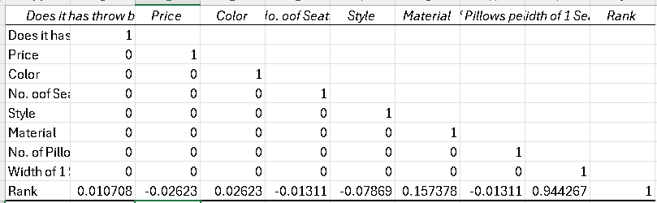
Figure 6: The Correlation Matrix.
  - Correlation Matrix:
Figure 6 shows a correlation matrix of the data. This step was done on the data with dummy variables in Figure 5 to make sure that the data is still orthogonal. The result shows that the data design is still orthogonal where it was able to measure the correlation scores. Now, we can conduct regression analysis.
- Regression Analysis:
  - Dependent and Independent Variables:
In this analysis, I set “Rank” to be the dependent variable and the 8 attributes to be the independent variable.
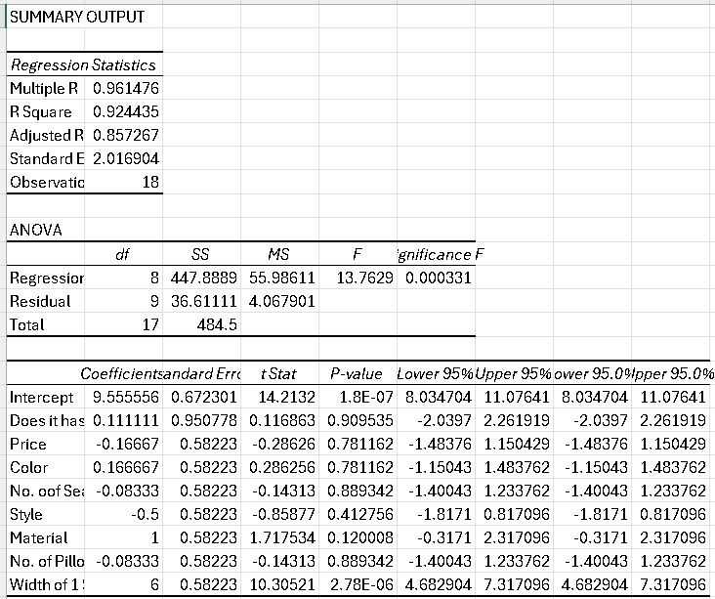
Figure 7: The Results of Regression Analysis.
  - Regression Results:
Figure 7 shows the result of regression. The R squared value is much higher than 0.7 which indicates that there is a strong level of fit between “Rank” and the 8 attributes. Although, Figure 7 shows that some p-values are lower than 0.05. These variables should be excluded because these independent variables are considered to be insignificant on 95% confidence level. As we can see in Figure 7, only “Width of 1 seat” has a p-value lower than 0.05. Therefore, all attributes will be excluded except “Width of 1 seat” because they have p-value higher than 0.05 on 95% confidence level, which means the independent variable is insignificant.
  - Reset Independent and Dependent Variables:
The dependent variable will remain “Rank” because it is the target variable in our case study. The independent variable will be only the attribute “Width of 1 seat”.

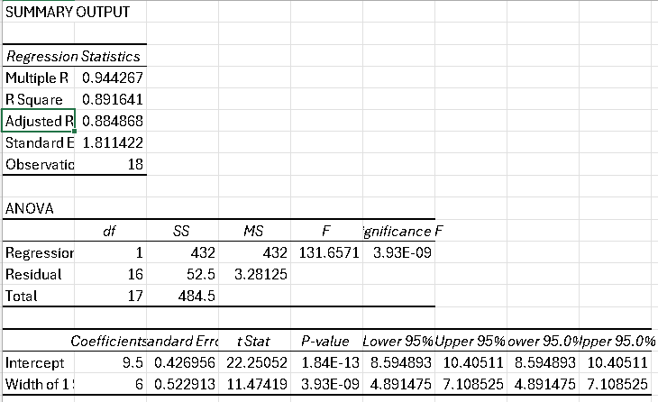
Figure 8: The Results of The Modified Regression Analysis.
  - Regression Results:
Figure 8 shows the result of regression analysis. The R squared value is higher than 0.7, which is 0.892, which indicates that there is a strong level of fit between “Rank” and the “Width of 1 seat” attribute. All p-values are less than 0l05, which means the independent variable is valid. To formulate the regression equation, I can take the coefficients shown in Figure 7. The regression equation to predict the rescaled rank will be as follows:
Predicted Rescaled Rank = 9.5 + 6 (Width of 1 seat).
- Conclusion:
The conjoint analysis and regression analysis results showed valuable insights about the factors that influence consumer preferences for sofa combinations of attributes. Conjoint analysis highlighted the importance of various attributes. Regression analysis showed us that the "Width of 1 seat" attribute is the most important attribute in identifying the customers preferences when it comes to sofa product combinations. It had the most impact on consumer rankings. I recommend for furniture designers and marketers to focus on the size of seat width. The wider the 1 seat of sofa is the more preferred the sofa would be.

References
Conjointly. (n.d.). What is conjoint analysis? (with examples). Conjointly. Retrieved November 12, 2024, from https://conjointly.com/guides/what-is-conjoint-analysis/

